Project Overview Template Project Characteristics

This document contains many project management related tables to be filled by the participants of the I3 course.

# Document version

Each time the document will be changed, please record in Table 1.

Table 1: Document version

|  |  |  |  |  |  |
| --- | --- | --- | --- | --- | --- |
| Nr. | Date | Version | Altered chapters | Type of altering | Author |
| 1 | 24.03.2025 | 1.1 | all | Creation | Max Schneeberger |
| 2 |  |  |  |  |  |
| 3 |  |  |  |  |  |
| 4 |  |  |  |  |  |
| 5 |  |  |  |  |  |

# Project information

*Please provide important facts for your project, e.g. acronym, title, proposed period, principal investigator and contractor.*

Table 2: Overall project information

|  |  |  |  |  |
| --- | --- | --- | --- | --- |
| Project |  | | | |
| Acronym | FLARE | | | |
| Title | Impacts of land use changes (2001-2021) on wildfire risk in San Diego County, California | | | |
| Period | Start: | 01.03.2025 | End: | 30.06.2025 |
| Principal investigator | Max Schneeberger | | | |
| Contractor | San Diego County Fire Protection District / California Office of Emergency Services | | | |

# Project Content and Project Goals

*Please provide an overview of your project with its main activities. Additionally give some information on the purpose, benefits and target groups as well as the proposed goals of your project. Please also provide explicit information on those aspects of the overall challenges, which you will not tackle with your project.*

Table 3: Project Content and Project Goals

|  |
| --- |
| Content & Goals |
| Project description *(~100-150 words)* |
| Worldwide, wildfires have increased dramatically in recent years, driven not only by climate change but also by changes in land use. Wildfires not only cause significant financial damage but also have far-reaching consequences for human health and the environment. While the scientific community agrees that the type of land use has a significant impact on wildfire risk, there is a lack of knowledge about how the change in land use is associated with the increase in wildfire damage. This study hypothesizes that the expansion of wildland urban interfaces has been a key factor in this trend. To examine this, this research investigates the impacts of land use change on the occurrence, frequency and severity of wildfire damage in San Diego County, California, from 2001 to 2021. Publicly available, historical and current land use data, historical wildfire data, and topographic data will be utilized. ArcGIS Pro will serve as the main software package. The methodologies include raster calculations and the development of literature-based metrics to compare the temporal changes in land use and their impact to fire susceptibility. |
| Project purpose, benefits and target group description *(~100 words)* |
| The target groups for the project are the San Diego County Fire Protection District and the California Office of Emergency Services. Those two agencies have the main responsibility in wildfire management in California respectively San Diego. The main purpose of the project is to help policy makers to establish sensible land use policies in the context of wildfires. Specifically, the derived results will guide the contractors in where to focus their mitigation measures of urban sprawl in the wildland urban interface. This is done by showcasing whether the expansion of wildland urban interfaces from 2001 – 2021 is intersecting with up-to-date wildfire risk areas. |
| Project objectives (please also include a listing of the sub-goals) *(~100 words)* |
| * Development of wildland urban interface expansion map addressing the timespan from 2001 to 2021: this map will showcase where wildland urban interfaces (the areas where the built environment spreads into the natural environment) expanded * Development of up-to-date wildfire risk map: This map will showcase the areas with the highest wildfire risk. It is made by combining metrics such as probability and susceptibility of wildfires occurring at a specific location as well as the vulnerability and the economic value of the assets affected. * Urban sprawl mitigation focus map: This map is a combination of the previous two mentioned maps and will help decision makers to decided where to focus efforts to mitigate urban sprawl. |
| Non-Goals |
| * Predicting future wildfires: the project will only deal with past and current phenomena and does not make an effort to predict the future risk of wildfires * As mentioned in the introduction, the major contributor to the increasing wildfires in recent years has been climate change. This project however will primarily focus on land use change and its impact on wildfires will addressing climate change only scarcely |

# Frame of the project

*Please provide a description of the existing situation. Therefore, please describe the actual state and the identified challenges. As a second part, please also provide the most important information with regard to the proposed project period and the most important dates (Kick-off, interim/mid-term report/presentation, final report, paper submission etc.).*

Table 4: Frame of the project – Part 1

|  |
| --- |
| Context |
| Up-to-date status *(~50-100 words)* |
| The project is making good progress: a first draft run of the WUI extension workflow has been carried out showing promising results. The next steps will be to start with the wildfire risk mapping workflow. |
| Project setting *(~50 Wörter)* |
| The project focuses on analyzing land use changes in San Diego County (2001–2021) to assess wildland-urban interface (WUI) expansion and its overlap with wildfire risk zones. Using GIS-based methods, wildfire data, and risk mapping techniques, the study aims to support land management decisions in mitigating wildfire hazards in high-risk areas. |

Table 5: Frame of the project – Part 2

|  |  |  |  |  |  |
| --- | --- | --- | --- | --- | --- |
| Time frame of the project | | | | | |
| Start: | | 01.03.2025 | | **End:** | 30.06.2025 |
| Important Dates | | | | | |
| 1 | 06.05.2025 | | Mid-Term-Presentation | | |
| 2 | 24.06.2025 | | Final Poster Presentation & Submission | | |
| 3 | 30.06.2025 | | Submission of the project achievements | | |

# Resources & Budget

*Please provide information on the project lead and the project team. Please include information on name, role and qualification. Additionally provide information about the planned resources with regard to personal costs and other costs.*

Table 6: Resources and Budget – Part 1

|  |
| --- |
| Project Team |
| Project Lead |
| Name: Max Schneeberger  Role: Lead  Qualfication: BSc Cartography and Geoinformation |
| Project Team |
| - |

Table 7: Resources and Budget – Part 2

|  |
| --- |
| Resources |
| Personal costs |
| 6000 EUR |
| Project costs |
| - |
| Other Costs |
| 2000 EUR (Hardware) |

# Project structure, description and risk matrix

*Please provide a description about your work plan (work breakdown structure) your work packages in tabular and graphical form.*

## Work packages overview

Table 8: Work packages overview

|  |  |  |
| --- | --- | --- |
| WP | Name of the Work Package | Time Frame [to – from] |
| 0 | Project Management | 01.03.2025 – 30.06.2025 |
| 1 | Project Initiation | 01.03.2025 – 30.04.2025 |
| 2 | Main Analysis Phase | 01.04.2025 – 15.05.2025 |
| 3 | Streamlining Outcomes | 01.05.2025 – 08.06.2025 |
| 4 | Presentation of Outcomes | 01.06.2025 – 30.06.2025 |

## Work Breakdown Structure (WBS)

Create a work breakdown structure for your work packages including the important tasks.

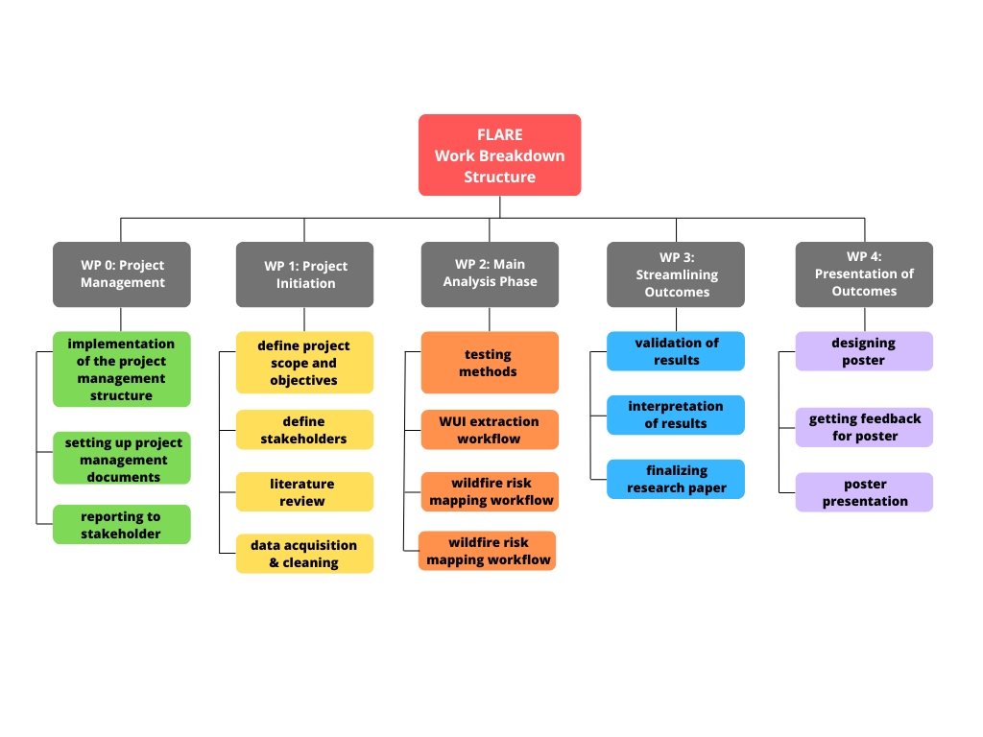

Figure 1 Work breakdown Structure

## Detailed work plan

*Please document the goals, content and expected results for each work package. Provide information on the planned approach and methods you want to apply as well as the expected results (including the planned milestones and deliverables). As a first work package please use ‘project management‘.*

Table 9: Detailed Work Plan – WP0

|  |  |  |  |
| --- | --- | --- | --- |
| WP 0 | Project management | Duration | 01.03.2025 – 30.06.2025 |
| Project Lead | **Project team** | | |
| Max Schneeberger | - | | |
| Objectives | | | |
| The objectives of this work package are to implement the overall project management structure on GitLab and setting up the related documents. Furthermore, the finished tasks shall be documented and reported in GitLab throughout the whole course of the project. | | | |
| Content & Tasks | | | |
| * 0.1: implementation of the project management structure * 0.2: setting up the project management documents * 0.3: reporting to stakeholders | | | |
| Expected results | | | |
| The expected results for this work package are a well-structured documentation of the project in GitLab and proper reporting of the tasks to the stakeholders throughout the whole course of the project. | | | |
| Milestones & Deliverables | | | |
| D1: Consulting session 1 completed  D2: Consulting session 2 completed  D3: Consulting session 3 completed  D4: Consulting session 4 completed | | | |

Table 10: Detailed Work Plan – WP1

|  |  |  |  |  |
| --- | --- | --- | --- | --- |
| WP 1 | Project Initiation | Duration | | 01.03.2025 – 30.04.2025 |
| Project Lead | | | **Project team** | |
| Max Schneeberger | | | - | |
| Objectives | | | | |
| The objectives of this work package are to initialize the project with defining the scope and objectives of the project as well as addressing stakeholders. Furthermore, this work package includes an in-depth literature review as well as data acquisition. | | | | |
| Content & Tasks | | | | |
| * 1.1: define project scope and objectives * 1.2: define stakeholders * 1.3: literature review * 1.4: data acquisition & cleaning | | | | |
| Expected results | | | | |
| With the completion of this work packages it is expected that all the tasks need for initialization of the project are completed and the main analysis phase can begin. | | | | |
| Milestones & Deliverables | | | | |
| M1 Definition of Stakeholders completed  M2 literature approaching completion  D1 data acquisition & cleaning completed | | | | |

Table 11: Detailed Work Plan – WP*2*

|  |  |  |  |  |
| --- | --- | --- | --- | --- |
| WP 2 | Main Analysis Phase | Duration | | 01.04.2025 – 15.05.2025 |
| Project Lead | | | **Project team** | |
| Max Schneeberger | | | - | |
| Objectives | | | | |
| The objectives of this work package include performing a first initial test of the suggested methods chosen for the project. Furthermore, wildland urban interface extraction workflow will be performed as well as a wildfire risk mapping workflow. Finally, the results from the WUI extraction workflow and the wildfire risk mapping workflow will be integrated and merged. | | | | |
| Content & Tasks | | | | |
| * 2.1: testing methods * 2.2: WUI extraction workflow * 2.3: wildfire risk mapping workflow * 2.4: integrating results of WT 2.2 & WT 2.3 | | | | |
| Expected results | | | | |
| After completion of this work package it is expected that preliminary desired results are available and ready for validation and interpretation. | | | | |
| Milestones & Deliverables | | | | |
| M3 method testing completed  D1 preliminary results available | | | | |

**Table 12: Detailed Work Plan – WP3**

|  |  |  |  |  |
| --- | --- | --- | --- | --- |
| WP 3 | Streamlining Outcomes | Duration | | 01.05.2025 – 08.06.2025 |
| Project Lead | | | **Project team** | |
| Max Schneeberger | | | - | |
| Objectives | | | | |
| The main objectives of this work package are to validate and interpret the results acquired from WP 2. Furthermore, the research paper of the project shall be finished and so that the work on the final presentation can start. | | | | |
| Content & Tasks | | | | |
| * 3.1: validation of results * 3.2: interpreting results * 3.3 finalizing research paper | | | | |
| Expected results | | | | |
| After finishing this work package, it is expected that all analysis work is done including interpreting of the results and documenting the outcomes in the research paper. Furthermore, the results should be ready to be presented in the final presentation. | | | | |
| Milestones & Deliverables | | | | |
| M4 result interpretation completed  D1 research paper finisehd | | | | |

**Table 13: Detailed Work Plan WP4**

|  |  |  |  |  |
| --- | --- | --- | --- | --- |
| WP 4 | Presentation of Outcomes | Duration | | 01.06.2025 – 30.06.2025 |
| Project Lead | | | **Project team** | |
| Max Schneeberger | | | - | |
| Objectives | | | | |
| The primary objectives of this work package are the illustrative presentation of the results in form of a poster presentation | | | | |
| Content & Tasks | | | | |
| * 4.1: designing poster * 4.2: getting feedback for poster * 4.3 poster presentation | | | | |
| Expected results | | | | |
| After finishing this work package the stakeholders will have a clear understanding of the outcomes of the project and be able to apply them to their use case. | | | | |
| Milestones & Deliverables | | | | |
| M5 feedback for poster received  D1 poster presentation done | | | | |

## Milestone plan

*Please provide a summary of the planned milestones and provide an according overview graphic.*

Table 14: Milestone plan

|  |  |  |
| --- | --- | --- |
| MS | Name | Date Completion |
| M1 | **Definition of Stakeholders completed:**  After this milestone has been completed, the stakeholders and target group of the project will be defined and further work can be streamlined to the needs of said contractors. | 24.03.2025 |
| M2 | **Literature review approaching completion:**  This milestone deals with a decision point in the workflow where it will be assessed in which direction the research evolves (depending on the research question) | 14.04.2025 |
| M3 | **Method testing completed:**  After completion of this milestone, a first test run of the planned methods will have been conducted and the methods to be used in the main analysis will have been selected. | 15.04.2025 |
| M4 | **Result interpretation completed:**  This milestone deals with the interpretation of the results. After completion, the results are ready to be documented in the final research paper. | 15.05.2025 |
| M5 | **Feedback for poster received:**  The completion of this milestone should help the principial investigator with the poster design and make sure that the results are visualized understandably for the stakeholders. | 24.06.2025 |

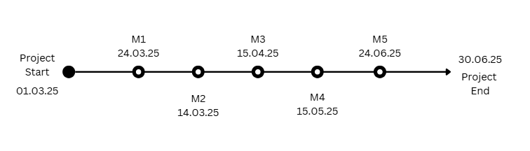

Figure 2 Milestones

## Gantt Chart

*Please provide an image of your Gantt chart as overview graphics. Please attach the Gantt chart and its monthly updates in addition to this document.*

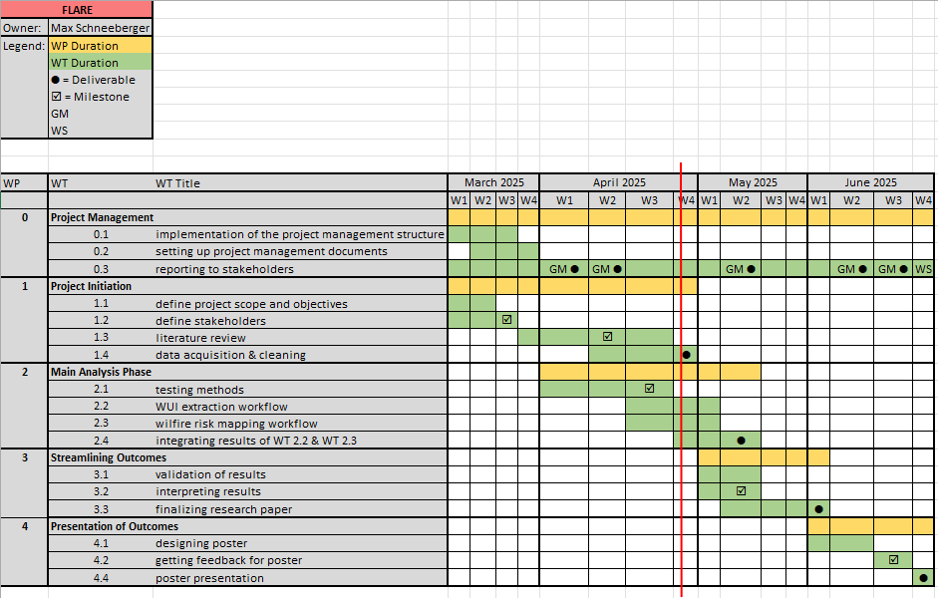

Figure 3: Gantt Chart

## Risk Matrix

*In this table, please provide the important risk information. Please categorize the risks accordingly. ([****L****]ow, [****M****]edium, [****H****]igh], [****C****]leared) as well as your mitigation strategy. Please update this list accordingly during your project execution time frame.*

Table 15: Risk matrix

|  |  |  |  |  |  |
| --- | --- | --- | --- | --- | --- |
| No | Risk | Potential adverse impact | Risk level* | Risk management strategy | Responsibility |
| 1 | Data Availability and Quality Issues – Incomplete, outdated, or low-resolution geospatial datasets. | Delays in analysis, inaccurate results, and difficulty in validating findings. | C | Verify dataset availability early, use multiple sources, and apply data cleaning techniques to improve accuracy. | Max Schneeberger |
| 2 | Software or Hardware Limitations – Issues with ArcGIS Pro, Python scripts, or computing power. | Slower data processing, potential software crashes, and inability to perform complex analyses. | L | Ensure software is up to date, use cloud-based computing resources if needed, and allocate backup workstations. | Max Schneeberger |
| 3 | Time Constraints and Scope Creep – Unexpected complexities in data processing or analysis requiring more time. | Project delays, missed deadlines, or incomplete research findings. | M | Develop a detailed project timeline with buffer periods, prioritize key objectives, and regularly review progress. | Max Schneeberger |
| 4 | Interdisciplinary Knowledge Gaps – Challenges in understanding key wildfire-related concepts from ecology, climatology, and land management. | Misinterpretation of wildfire risk factors, leading to flawed analysis or incorrect conclusions. | C | Conduct an extensive literature review on wildfire science and consult knowledgeable colleagues or professors within the department for guidance if necessary | Max Schneeberger |

# Additional comments

*Add additional comments if necessary.*

Table 16: Additional comments

|  |
| --- |
| Comments |
| - |

# Approval

*Please provide further information if necessary.*

Table 17: Approval

|  |  |  |  |
| --- | --- | --- | --- |
| Freigabe | | | |
| Date: | 25.03.2025 | **Date**: | 25.03.2025 |
|  | |  | |
| Signature principal investigator | | Signature project lead/contractor | |

# Attachments

*Attachment 1: Gantt chart (biweekly updated).*

